Farm to School Farm Fresh Menu Served in the Cafeteria at lunch time Tuesday , Wednesday & Thursday
Same Day Purchase or Pre Order Specials
Pilot project to offer local, fresh, salads and soups to CCS students & staff
Sponsored by Farm to Cafeteria Canada, Centreville Community School & Strawberry Hill Farm

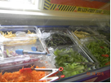 | Tuesday Sept 22  Salad Bar & Roll | Wed. Sept 23  Salad Bar & Roll | Thurs, Sept 24  Salad Bar & Roll | Salad Bar Items  Mixed Greens, Spinach,, Tomatoes, Cucumbers  Red Onion  Celery  Grated Carrot  Hard Boiled Egg or Cheese  WW Roll  Salad Dressing  Soup: $2.50  Full Course Salad: $2.50  Soup/ Salad Combo: $4.00  Side Salad or small dish one veggie of choice: $1.00
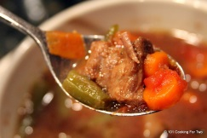 | Or  Hamburger Vegetable Soup & WW Roll | Or  Hamburger Vegetable Soup & WW Roll | Or  Hamburger Vegetable Soup & WW Roll
 | Tuesday Sept 29  Salad Bar & Roll | Wed. Sept 30  Salad Bar & Roll | Thurs, Oct 1  Salad Bar & Roll
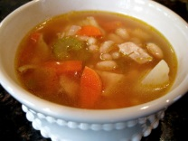 | Or  Chicken Vegetable Soup & Roll | Or  Chicken Vegetable Soup & Roll | Or  Chicken Vegetable Soup & Roll
 | Tuesday Oct 6  Salad Bar & Roll | Wed. Oct 7  Salad Bar & Roll | Thurs, Oct 8  Salad Bar & Roll
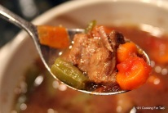 | Or  Hamburger Vegetable Soup & WW Roll | Or  Hamburger Vegetable Soup & WW Roll | Or  Hamburger Vegetable Soup & WW Roll

Student Name:________________________Home Room:_____________________

Circle your order. Send money to home room teacher.
Purchase a Meal Card:
3 soup or full course salads : 7.50 3 Soup & Salad: $12.00

Purchase 10 soup or full course salads: 22.50 Get next two free

Purchase 10 soup & salad combo- $40.00 Get next two free

Side salad or small dish with one veggie from salad bar of student choice: $1.00 each
10 for $10.00 with next two free

Purchase daily at salad bar:
Soup & Roll: $2.50
Main Course Salad & Roll: $2.50
Side Salad or 1 Veggie in small dish: $1.00

